1. Let’s create a login page with user name and password.
2. We will use LoginComponent to contain all of the code of that.
3. 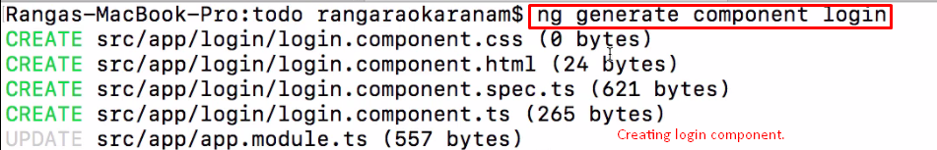
4. 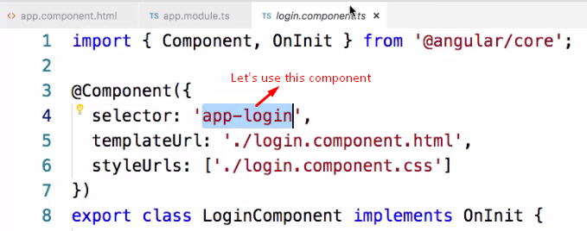
5. 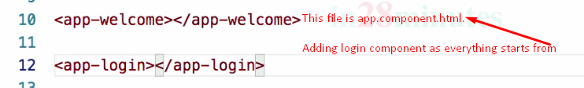
6. 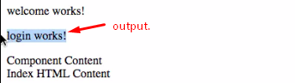
7. 
8. 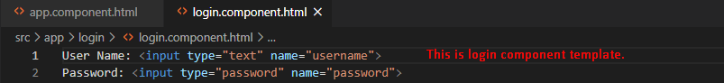
9. 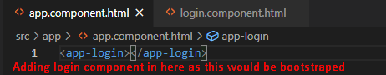
10. 